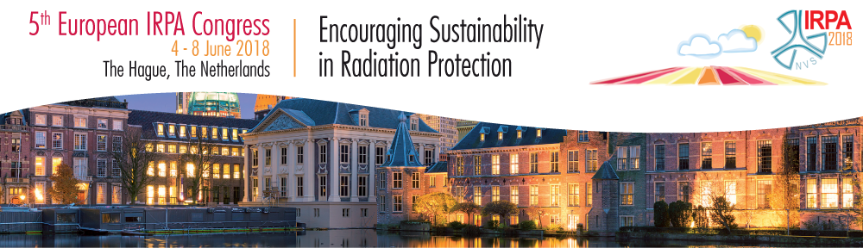
Dear Colleague,
This newsletter is mainly dedicated to the presentation of the Congress programme, but starts with a final call for abstracts.
Submitting abstracts
Final deadline for submitting abstracts for IRPA2018-congress fastly approaching! Submit your abstract not later than March 4th. Abstracts will in principle be considered for acceptance as poster only.
Congress Programme
Last week the scientific programme including the refreshers has largely been finished. Please click here for an overview of the congress programme.
Registration
Registration for this congress can be done via www.irpa2018europe.com/registration.

Social media
- Please join the IRPA2018 LinkedIn group to stay informed on all the congress information https://www.linkedin.com/groups/8633053
- Follow us on our Twitter-account: #IRPA2018
More information
You will find further detailed information on our website:
- www.irpa2018europe.com
General Congress News
- www.irpa2018europe.com/registration
Registration
- www.irpa2018europe.com/registration/call-for-abstracts
Call for abstracts - only abstracts for acceptance as poster
- For questions please contact our congress secretariaat at info@irpa2018europe.com
We hope to welcome you on June 4, 2018 in The Hague,
The Local Organizing Committee of the 5th European IRPA Congress
Detailed information can be found in the 2nd announcement on our website.
You are kindly requested to distribute this newsletter among other interested professionals.

IRPA 2018 The Hague
T.: +31 (0)85 90 22 833
E.: info@irpa2018europe.com
W.: www.irpa2018europe.com

